#include<stdio.h>

#include<conio.h>

#include<math.h>

#include<graphics.h>

func();

int main()

{

int gd=DETECT,gm;

int a,b,e,option;

char c[10],d[10];

initgraph(&gd,&gm,"C:\\TC\\BGI");

cleardevice();

printf("\n 1. ax^n\n 2. asin(bx)\n 3. acos(bx)\n 4. atan(bx)\n 5. acosec(bx)\n 6. asec(bx)\n 7. acot(bx)");

printf("\n 8. log(ax)\n 9. e^(ax)\n10. a^x\n\n");

printf("Choose function to differentiate\n");

scanf("%d",&option);

cleardevice();

switch(option)

{

case 1:

printf("f(x)=ax^n\n");

printf("f'(x)=nax^(n-1)");

printf("\n\nEnter the values of a & n\n");

scanf("%d%d",&a,&b);

if(b==1&&a>0)

{

line(50,50,50,200); //graph of f(x) for linear function

line(20,180,200,180);

setcolor(YELLOW);

line(50,180,180,80);

line(50,179,180,79);

printf("\nf(x)=%dx\n",a);

printf("\n f'(x)=%d\n",a);

sprintf(c,"y=%dx",a);

setcolor(WHITE);

outtextxy(120,80,c);

outtextxy(80,190,"Graph of f(x)");

outtextxy(370,190,"Graph of f'(x)");

line(350,50,350,200); //graph of f'(x) for linear function

line(320,180,500,180);

setcolor(RED);

line(352,120,500,120);

line(352,121,500,121);

sprintf(c,"y'=%d",a);

setcolor(WHITE);

outtextxy(400,110,c);

setcolor(3);

rectangle(0,360,70,390);

setcolor(WHITE);

}

if(b==1&&a<0)

{

line(110,50,110,200); //graph of f(x) for linear function (-ve)

line(20,180,200,180);

setcolor(YELLOW);

line(110,180,10,75);

line(110,179,10,74);

printf("\nf(x)=%dx\n",a);

printf("\n f'(x)=%d\n",a);

sprintf(c,"y=%dx",a);

setcolor(WHITE);

outtextxy(40,80,c);

outtextxy(120,190,"Graph of f(x)");

outtextxy(370,110,"Graph of f'(x)");

line(350,50,350,200); //graph of f'(x) for linear function (-ve)

line(320,120,500,120);

setcolor(RED);

line(352,170,500,170);

line(352,171,500,171);

sprintf(c,"y'=%d",a);

setcolor(WHITE);

outtextxy(400,160,c);

setcolor(3);

rectangle(0,360,80,390);

}

if(b==2&&a>0)

{

line(350,50,350,200); //graph of f'(x) for quadratic function

line(320,180,500,180);

setcolor(RED);

line(350,180,450,80);

line(350,179,450,79);

line(350,178,450,78);

printf("\nf(x)=%dx^2\n",a);

printf("\n f'(x)=%dx\n",a*b);

sprintf(c,"y=%dx^2",a);

setcolor(WHITE);

outtextxy(140,80,c);

outtextxy(80,190,"Graph of f(x)");

outtextxy(370,190,"Graph of f'(x)");

line(50,50,50,200); //graph of f(x) for quadratic function

line(20,180,200,180);

setcolor(YELLOW);

arc(50,98,270,30,80);

arc(50,99,271,31,80);

sprintf(c,"y'=%dx",a*b);

setcolor(WHITE);

outtextxy(430,110,c);

setcolor(3);

rectangle(0,360,90,390);

setcolor(WHITE);

}

if(b==2&&a<0)

{

line(350,50,350,200); //graph of f'(x) for quadratic function (-ve)

line(320,100,500,100);

setcolor(RED);

line(350,100,450,200);

line(350,101,450,201);

line(350,102,450,202);

printf("\nf(x)=%dx^2\n",a);

printf("\n f'(x)=%dx\n",a*b);

sprintf(c,"y=%dx^2",a);

setcolor(WHITE);

outtextxy(130,150,c);

outtextxy(80,90,"Graph of f(x)");

outtextxy(370,90,"Graph of f'(x)");

line(50,50,50,200); //graph of f(x) for quadratic function (-ve)

line(20,100,200,100);

setcolor(YELLOW);

arc(50,171,360,90,70);

arc(49,172,359,89,71);

sprintf(c,"y'=%dx",a*b);

setcolor(WHITE);

outtextxy(395,130,c);

setcolor(3);

rectangle(0,360,90,390);

setcolor(WHITE);

}

if(b>=3&&a>0)

{

line(350,50,350,200); //graph of f'(x) for cubic function

line(320,180,500,180);

setcolor(RED);

arc(350,107,270,30,70);

arc(350,107,271,31,71);

printf("\nf(x)=%dx^%d\n",a,b);

printf("\n f'(x)=%dx^%d\n",a*b,b-1);

sprintf(c,"y=%dx^%d",a,b);

setcolor(WHITE);

outtextxy(160,80,c);

outtextxy(80,190,"Graph of f(x)");

outtextxy(370,190,"Graph of f'(x)");

line(50,50,50,200); //graph of f(x) for cubic function

line(20,180,200,180);

setcolor(YELLOW);

arc(50,79,270,30,100);

arc(50,80,271,31,100);

sprintf(c,"y'=%dx^%d",a*b,b-1);

setcolor(WHITE);

outtextxy(430,110,c);

setcolor(3);

rectangle(0,360,110,390);

setcolor(WHITE);

}

if(b>=3&&a<0)

{

line(350,50,350,200); //graph of f'(x) for cubic function (-ve)

line(320,80,500,80);

setcolor(RED);

arc(350,154,360,90,72);

arc(348,154,360,90,72);

arc(349,154,359,90,72);

printf("\nf(x)=%dx^%d\n",a,b);

printf("\n f'(x)=%dx^%d\n",a*b,b-1);

sprintf(c,"y=%dx^%d",a,b);

setcolor(WHITE);

outtextxy(140,120,c);

outtextxy(80,70,"Graph of f(x)");

outtextxy(370,70,"Graph of f'(x)");

line(50,50,50,200); //graph of f(x) for cubic function (-ve)

line(20,80,200,80);

setcolor(YELLOW);

arc(50,181,360,90,100);

arc(49,182,359,89,101);

sprintf(c,"y'=%dx^%d",a*b,b-1);

setcolor(WHITE);

outtextxy(430,110,c);

setcolor(3);

rectangle(0,360,110,390);

setcolor(WHITE);

}

if(a==0)

{

func();

}

if(a>0&&b==0)

{

outtextxy(70,190,"Graph of f(x)");

outtextxy(370,190,"Graph of f'(x)");

outtextxy(400,165,"y'=0");

line(50,50,50,200); //graph of f(x) constant

line(20,180,200,180);

setcolor(YELLOW);

line(50,120,200,120);

printf("\nf(x)=%d\n",a);

printf("\n f'(x)=0\n");

sprintf(c,"y=%d",a);

setcolor(WHITE);

outtextxy(100,110,c);

line(350,50,350,200); //graph of f'(x) constant

line(320,180,500,180);

setcolor(RED);

line(350,180,500,180);

line(350,179,500,179);

setcolor(3);

rectangle(0,360,90,390);

}

if(a<0&&b==0)

{

outtextxy(70,110,"Graph of f(x)");

outtextxy(370,190,"Graph of f'(x)");

outtextxy(400,165,"y'=0");

line(50,50,50,200); //graph of f(x) constant (-ve)

line(20,120,200,120);

setcolor(YELLOW);

line(50,160,200,160);

printf("\nf(x)=%d\n",a);

printf("\n f'(x)=0\n");

sprintf(c,"y=%d",a);

setcolor(WHITE);

outtextxy(100,145,c);

line(350,50,350,200); //graph of f'(x) constant (-ve)

line(320,180,500,180);

setcolor(RED);

line(350,180,500,180);

line(350,179,500,179);

setcolor(3);

rectangle(0,360,90,390);

}

break;

case 2:

printf("f(x)=asin(bx)");

printf("\nf'(x)=abcos(bx)");

printf("\n\nEnter the values of a & b\n");

scanf("%d%d",&a,&b);

if(a==0||b==0)

{

func();

}

if((a<0&&b>0)||(a>0&&b<0))

{

outtextxy(100,170,"Graph of f(x)");

outtextxy(370,170,"Graph of f'(x)");

line(50,50,50,180); //graph of f(x) sine

line(20,130,230,130);

setcolor(YELLOW);

arc(70,130,180,360,20);

arc(70,130,180,360,19);

arc(110,130,0,180,20);

arc(110,130,0,180,19);

arc(150,130,180,360,20);

arc(150,130,180,360,19);

arc(190,130,0,180,20);

arc(190,130,0,180,19);

setcolor(WHITE);

line(350,50,350,180); //graph of f'(x) sine

line(320,130,500,130);

setcolor(RED);

arc(350,130,270,360,20);

arc(350,130,270,360,19);

arc(390,130,0,180,20);

arc(390,130,0,180,19);

arc(430,130,180,360,20);

arc(430,130,180,360,19);

arc(470,130,90,180,20);

arc(470,130,90,180,19);

setcolor(WHITE);

printf("\nf(x)=%dsin(%dx)\n",a,b);

printf("\n f'(x)=%dcos(%dx)\n",a*b,abs(b));

sprintf(d,"y=%dsin(%dx)",a,b);

outtextxy(80,90,d);

sprintf(c,"y'=%dcos(%dx)",a*b,abs(b));

outtextxy(380,90,c);

setcolor(3);

rectangle(0,360,150,390);

}

else

{

line(50,50,50,180); //graph of f(x)

line(20,130,230,130);

outtextxy(100,170,"Graph of f(x)");

outtextxy(370,170,"Graph of f'(x)");

setcolor(YELLOW);

arc(70,130,0,180,20);

arc(70,130,0,180,19);

arc(110,130,180,360,20);

arc(110,130,180,360,19);

arc(150,130,0,180,20);

arc(150,130,0,180,19);

arc(190,130,180,360,20);

arc(190,130,180,360,19);

setcolor(WHITE);

line(350,50,350,180); //graph of f'(x)

line(320,130,500,130);

setcolor(RED);

arc(350,130,0,90,20);

arc(350,130,0,90,19);

arc(390,130,180,360,20);

arc(390,130,180,360,19);

arc(430,130,0,180,20);

arc(430,130,0,180,19);

arc(470,130,180,270,20);

arc(470,130,180,270,19);

setcolor(WHITE);

printf("\nf(x)=%dsin(%dx)\n",a,b);

printf("\n f'(x)=%dcos(%dx)\n",a*b,abs(b));

sprintf(d,"y=%dsin(%dx)",a,b);

outtextxy(80,90,d);

sprintf(c,"y'=%dcos(%dx)",a*b,abs(b));

outtextxy(380,90,c);

setcolor(3);

rectangle(0,360,150,390);

}

break;

case 3:

printf("f(x)=acos(bx)");

printf("\nf'(x)=-absin(bx)");

printf("\n\nEnter the values of a & b\n");

scanf("%d%d",&a,&b);

if(a==0)

{

func();

}

if(a>0&&b==0)

{

line(50,50,50,200); //graph of f(x)

line(20,180,200,180);

outtextxy(70,190,"Graph of f(x)");

outtextxy(370,190,"Graph of f'(x)");

line(350,50,350,200); //graph of f'(x)

line(320,180,500,180);

sprintf(c,"y=%d",a);

outtextxy(100,100,c);

outtextxy(400,165,"y=0");

setcolor(RED);

line(350,180,500,180);

line(350,179,500,179);

setcolor(YELLOW);

line(50,120,200,120);

line(50,121,200,121);

printf("\nf(x)=%d",a);

printf("\n\n f'(x)=0");

setcolor(3);

rectangle(0,360,90,390);

}

if(a<0&&b==0)

{

line(50,50,50,200); //graph of f(x)

line(20,110,200,110);

outtextxy(70,100,"Graph of f(x)");

outtextxy(370,190,"Graph of f'(x)");

line(350,50,350,200); //graph of f'(x)

line(320,180,500,180);

sprintf(c,"y=%d",a);

outtextxy(100,140,c);

outtextxy(400,165,"y=0");

setcolor(RED);

line(350,180,500,180);

line(350,179,500,179);

setcolor(YELLOW);

line(50,150,200,150);

line(50,151,200,151);

printf("\nf(x)=%d",a);

printf("\n\n f'(x)=0");

setcolor(3);

rectangle(0,360,90,390);

}

if(a>0&&b>0)

{

printf("\nf(x)=%dcos(%dx)",a,b);

printf("\n\n f'(x)=%dsin(%dx)",-a*b,b);

sprintf(c,"y=%dcos(%dx)",a,b);

outtextxy(90,70,c);

outtextxy(80,150,"Graph of f(x)");

outtextxy(380,150,"Graph of f'(x)");

sprintf(c,"y'=%dsin(%dx)",-a*b,b);

outtextxy(390,70,c);

line(50,50,50,200); //graph of f(x)

line(20,110,200,110);

line(330,50,330,200);

line(300,110,500,110);

setcolor(YELLOW);

arc(50,110,0,90,20);

arc(50,110,0,90,19);

arc(90,110,180,360,20);

arc(90,110,180,360,19);

arc(130,110,0,180,20);

arc(130,110,0,180,19);

arc(170,110,180,270,20);

arc(170,110,180,270,19);

setcolor(RED);

arc(350,110,180,360,20);

arc(350,110,180,360,19);

arc(390,110,0,180,20);

arc(390,110,0,180,19);

arc(430,110,180,360,20);

arc(430,110,180,360,19);

arc(470,110,0,180,20);

arc(470,110,0,180,19);

setcolor(3);

rectangle(0,360,150,390);

}

break;

case 4:

printf("f(x)=atan(bx)");

printf("\nf'(x)=ab(sec(bx))^2");

printf("\n\nEnter the values of a & b\n");

scanf("%d%d",&a,&b);

printf("\nf(x)=%dtan(%dx)",a,b);

printf("\n\n f'(x)=%d(sec(%dx))^2",a*b,b);

setcolor(3);

rectangle(0,360,200,390);

break;

case 5:

printf("f(x)=acosec(bx)");

printf("\nf'(x)=-abcosec(bx)cot(bx)");

printf("\n\nEnter the values of a & b\n");

scanf("%d%d",&a,&b);

printf("\nf(x)=%dcosec(%dx)",a,b);

printf("\n\n f'(x)=%dcosec(%dx)cot(%dx)",-a*b,b,b);

setcolor(3);

rectangle(0,360,250,390);

break;

case 6:

printf("f(x)=asec(bx)");

printf("\nf'(x)=absec(bx)tan(bx)");

printf("\n\nEnter the values of a & b\n");

scanf("%d%d",&a,&b);

printf("\nf(x)=%dsec(%dx)",a,b);

printf("\n\n f'(x)=%dsec(%dx)tan(%dx)",a*b,b,b);

setcolor(3);

rectangle(0,360,250,390);

break;

case 7:

printf("f(x)=acot(bx)");

printf("\nf'(x)=-ab(cosec(bx))^2");

printf("\n\nEnter the values of a & b\n");

scanf("%d%d",&a,&b);

printf("\nf(x)=%dcot(%dx)",a,b);

printf("\n\n f'(x)=%d(cosec(%dx))^2",-a*b,b);

setcolor(3);

rectangle(0,360,250,390);

break;

case 8:

printf("f(x)=alog(bx)");

printf("\nf'(x)=(ab)/x");

printf("\n\nEnter the values of a & b\n");

scanf("%d%d",&a,&b);

printf("\nf(x)=%dlog(%dx)",a,b);

printf("\n\n f'(x)=%d/x",a*b);

setcolor(3);

rectangle(0,360,100,390);

break;

case 9:

printf("f(x)=e^(ax)");

printf("\nf'(x)=ae^(ax)");

printf("\n\nEnter the value of a\n");

scanf("%d",&a);

printf("\nf(x)=e^(%dx)",a);

printf("\n\n f'(x)=%de^(%dx)",a,a);

setcolor(3);

rectangle(0,345,150,375);

break;

case 10:

printf("f(x)=a^x");

printf("\nf'(x)=a^x(loga)");

printf("\n\nEnter the value of a\n");

scanf("%d",&a);

printf("\nf(x)=%d^x",a);

printf("\n\n f'(x)=%d^x(log%d)",a,a);

setcolor(3);

rectangle(0,345,150,375);

break;

}

getch();

return 0;

}

func()

{

outtextxy(70,190,"Graph of f(x)");

outtextxy(370,190,"Graph of f'(x)");

outtextxy(100,165,"y=0");

outtextxy(400,165,"y'=0");

line(50,50,50,200); //graph of f(x)

line(20,180,200,180);

setcolor(YELLOW);

line(50,180,200,180);

setcolor(WHITE);

line(350,50,350,200); //graph of f'(x)

line(320,180,500,180);

setcolor(RED);

line(350,180,500,180);

line(350,179,500,179);

printf("\nf(x)=0");

printf("\n\n f'(x)=0");

setcolor(3);

rectangle(0,360,80,390);

getch();

return 0;

}

**OUTPUTS:**

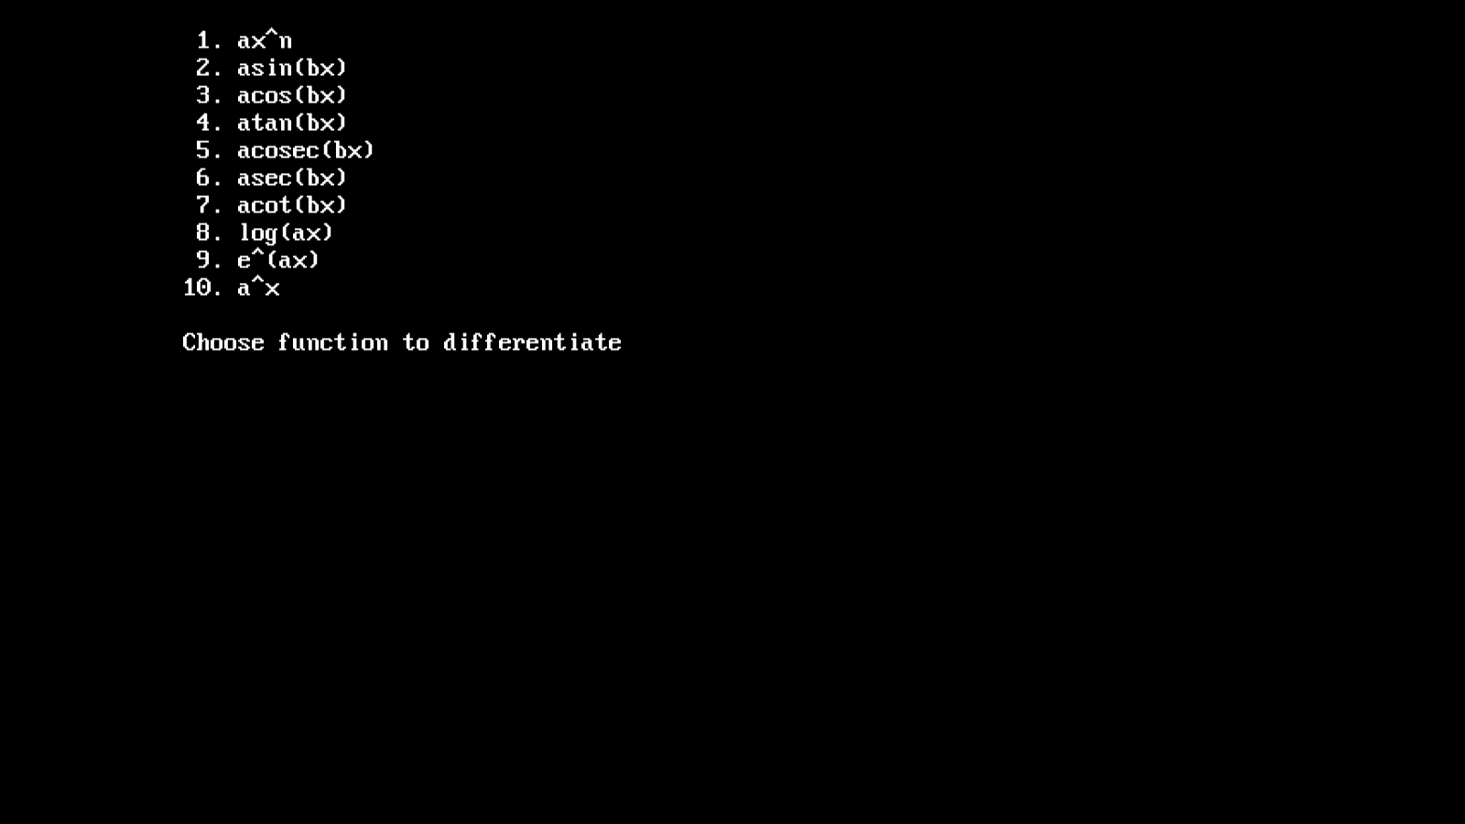

**DIFFERENTIABLE FUNCTIONS**

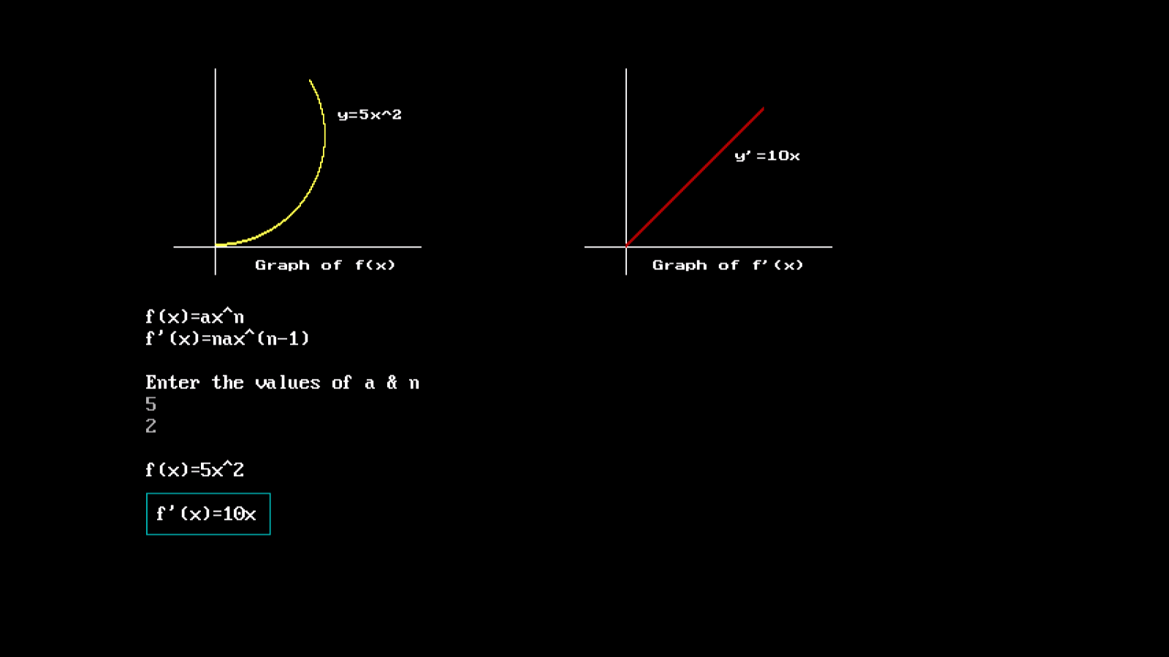

$f(x)={ax}^{n}$**, $f^{'}\left(x\right)={nax}^{n-1}$**

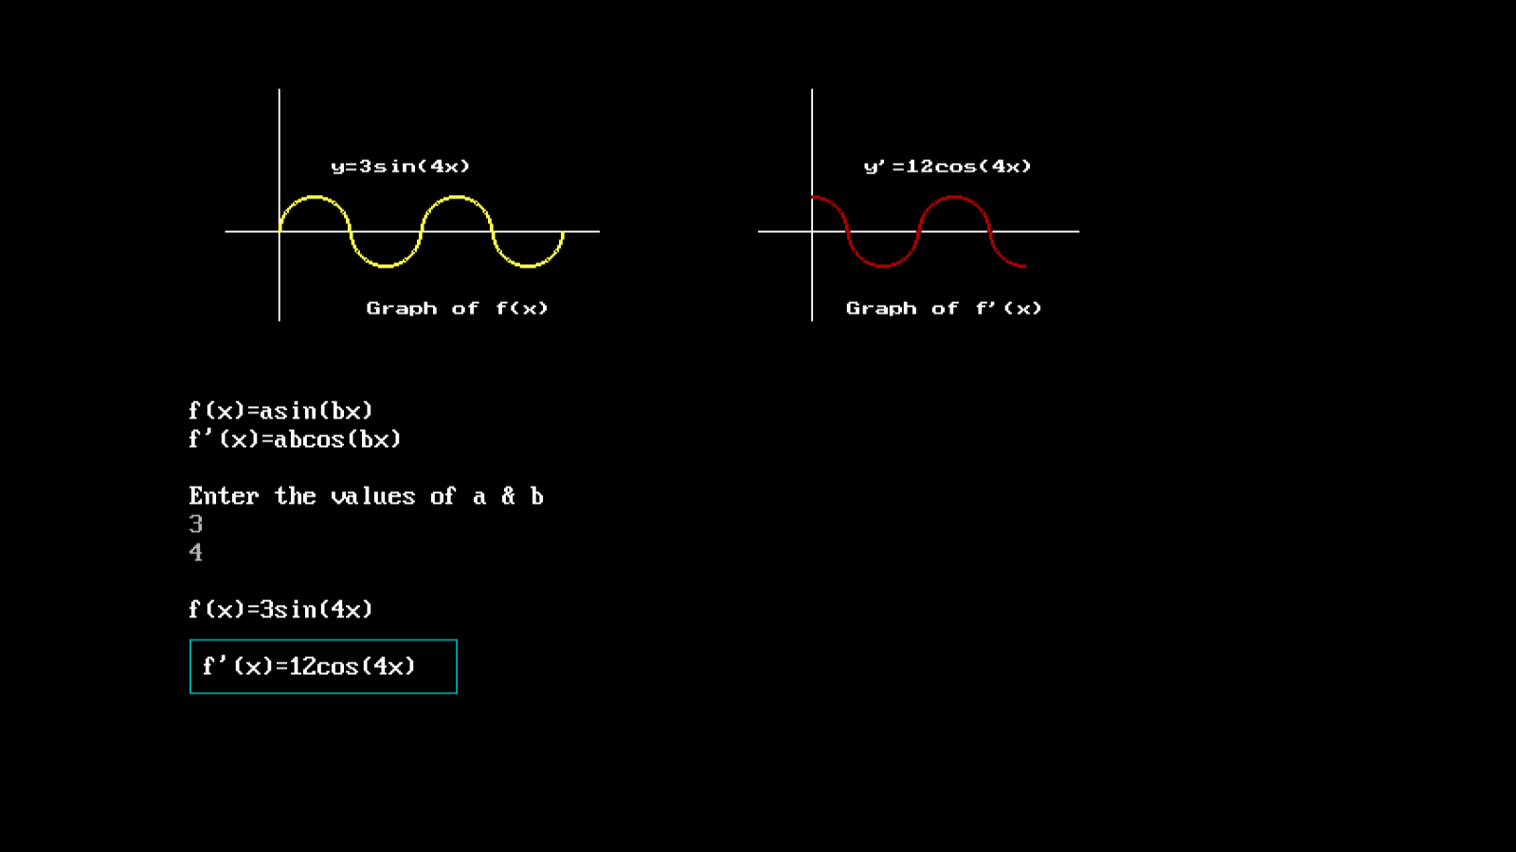

$f\left(x\right)=a sin{(bx})$**, $f^{'}\left(x\right)=ab cos{(bx)}$**